1) Path Loss vs Latitude:

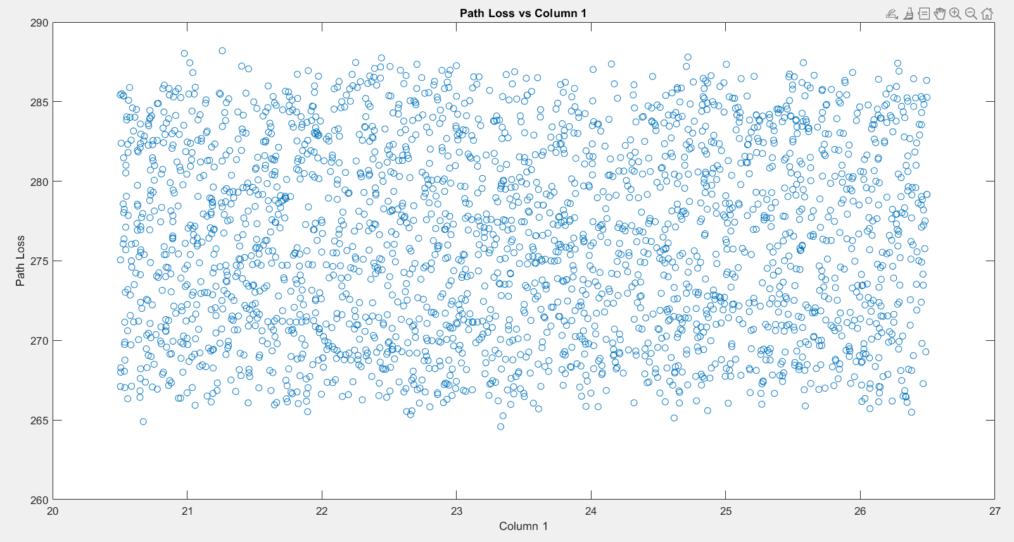

2) Path Loss vs Longitude:

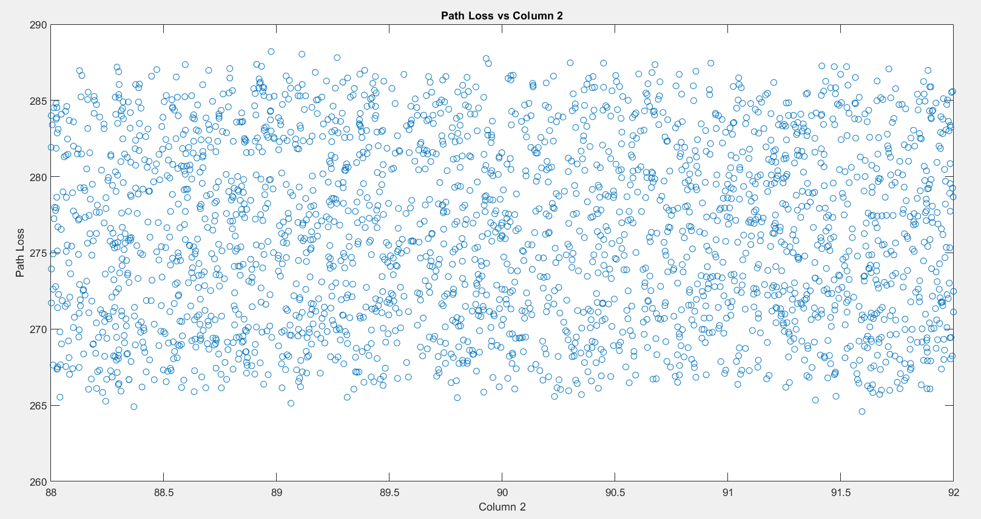

3) Path Loss vs Elevation:

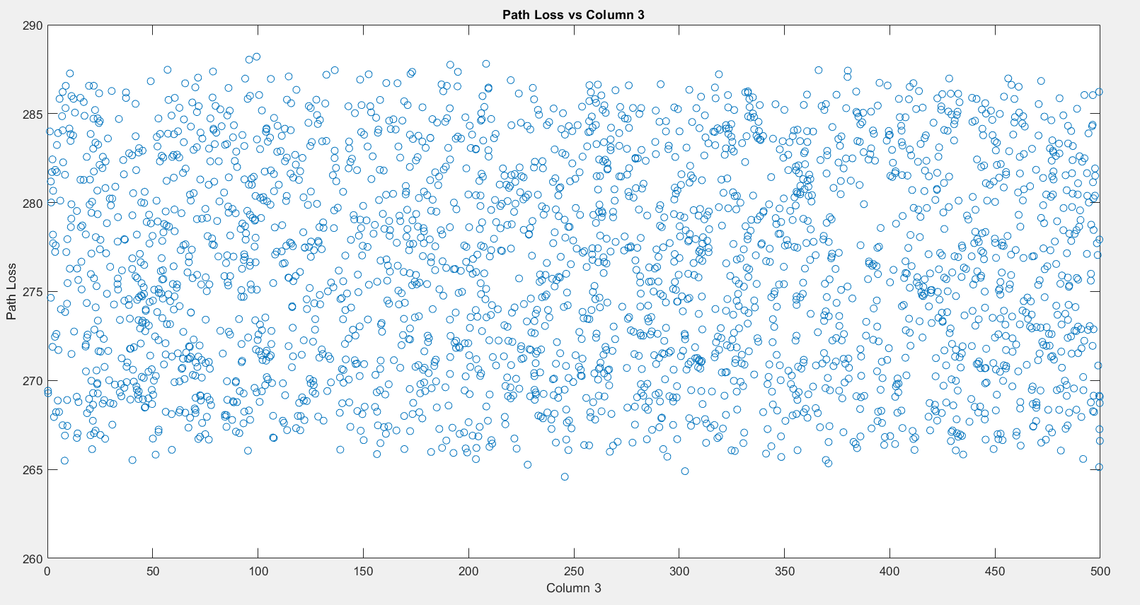

4) Path Loss vs Transmitter Height:

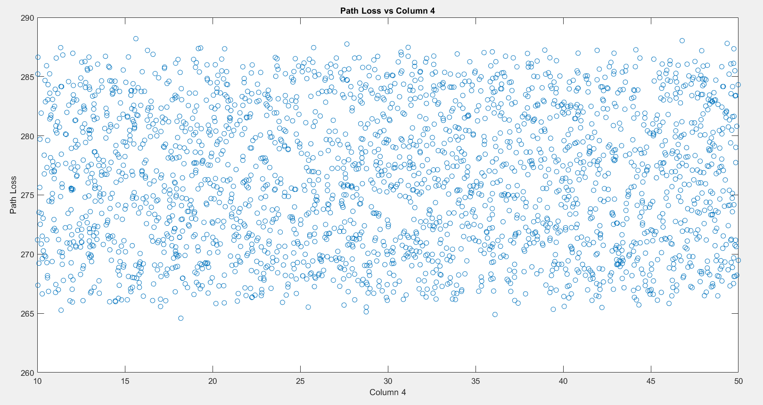

5) Path Loss vs Antenna Gain:

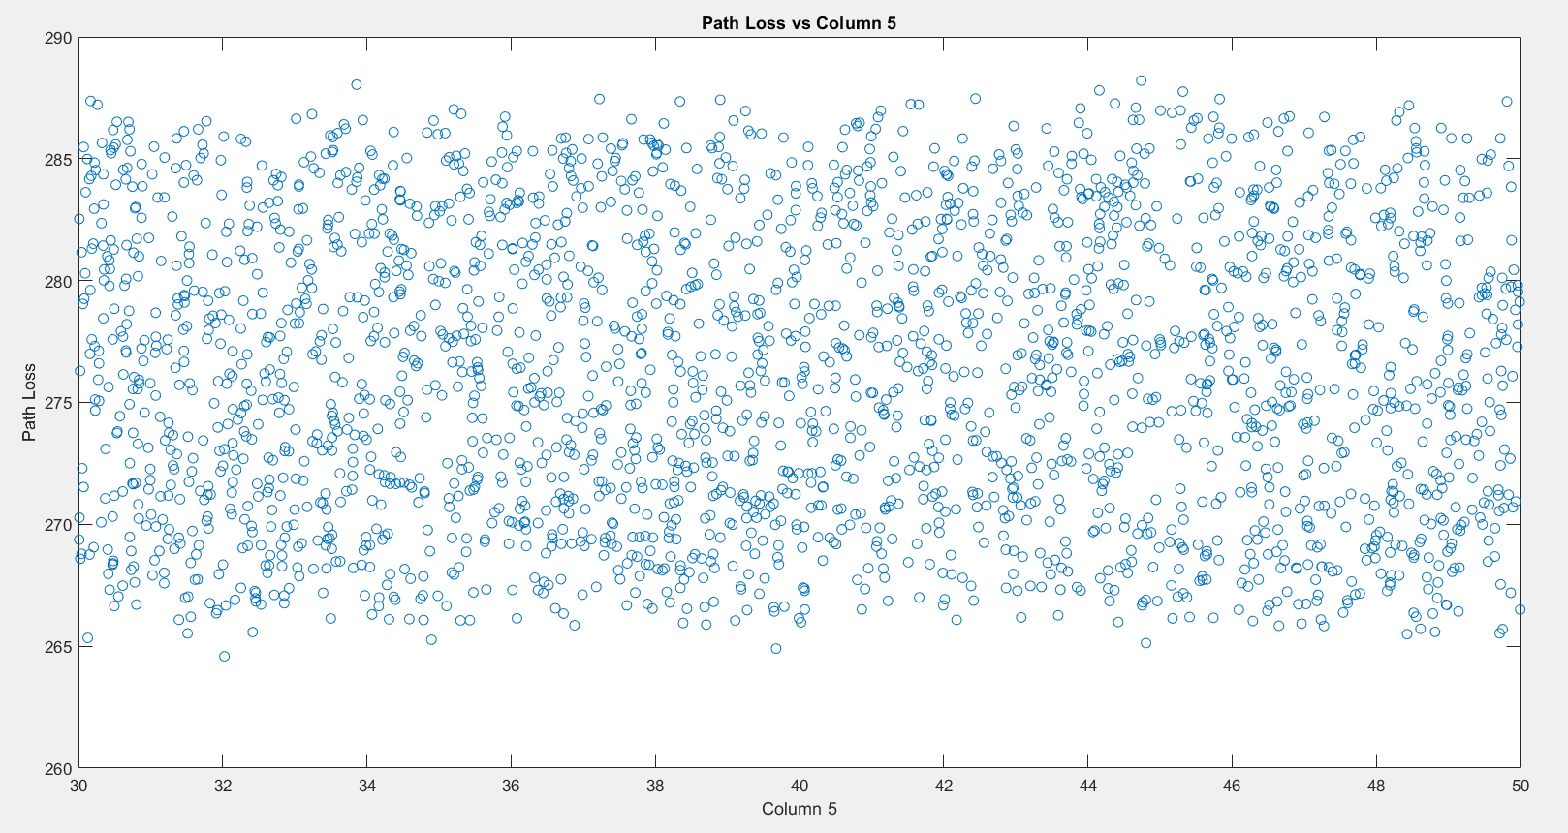

6) Path Loss vs Transmitter Power:

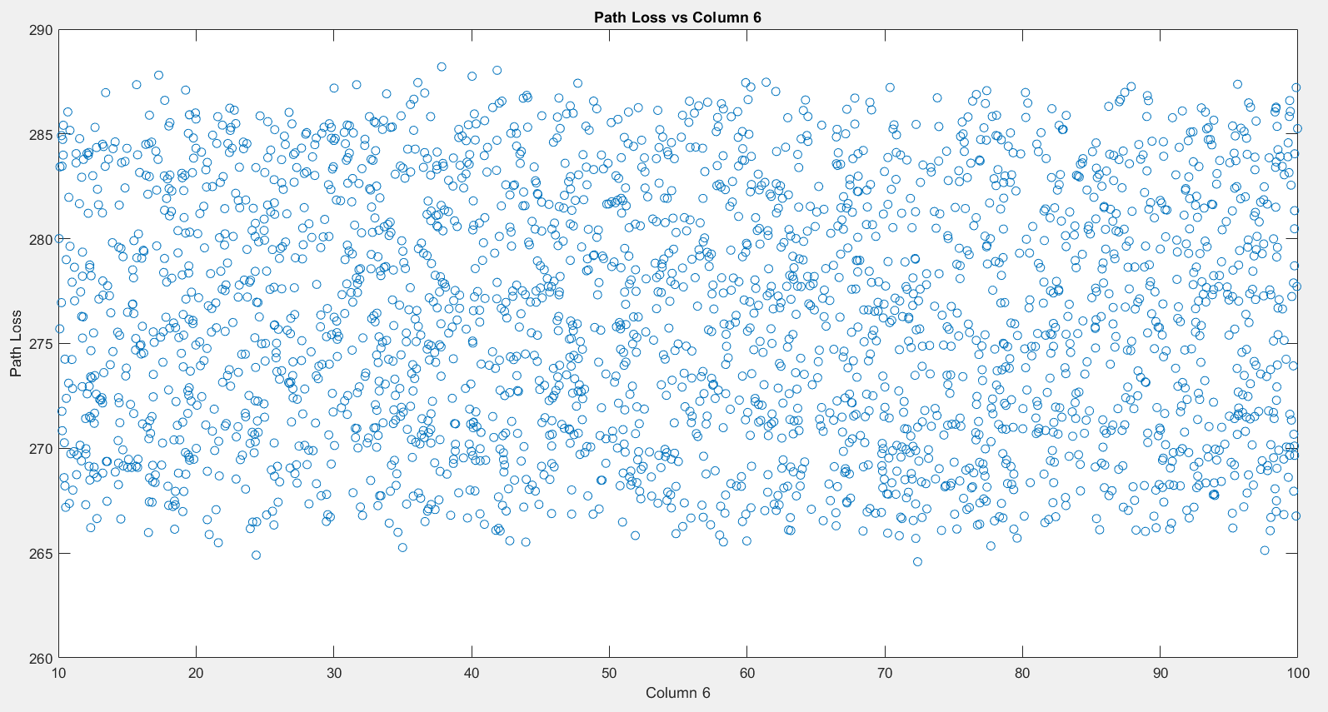

7) Path Loss vs Frequency Band:

Ku-band = 1

C-band =0

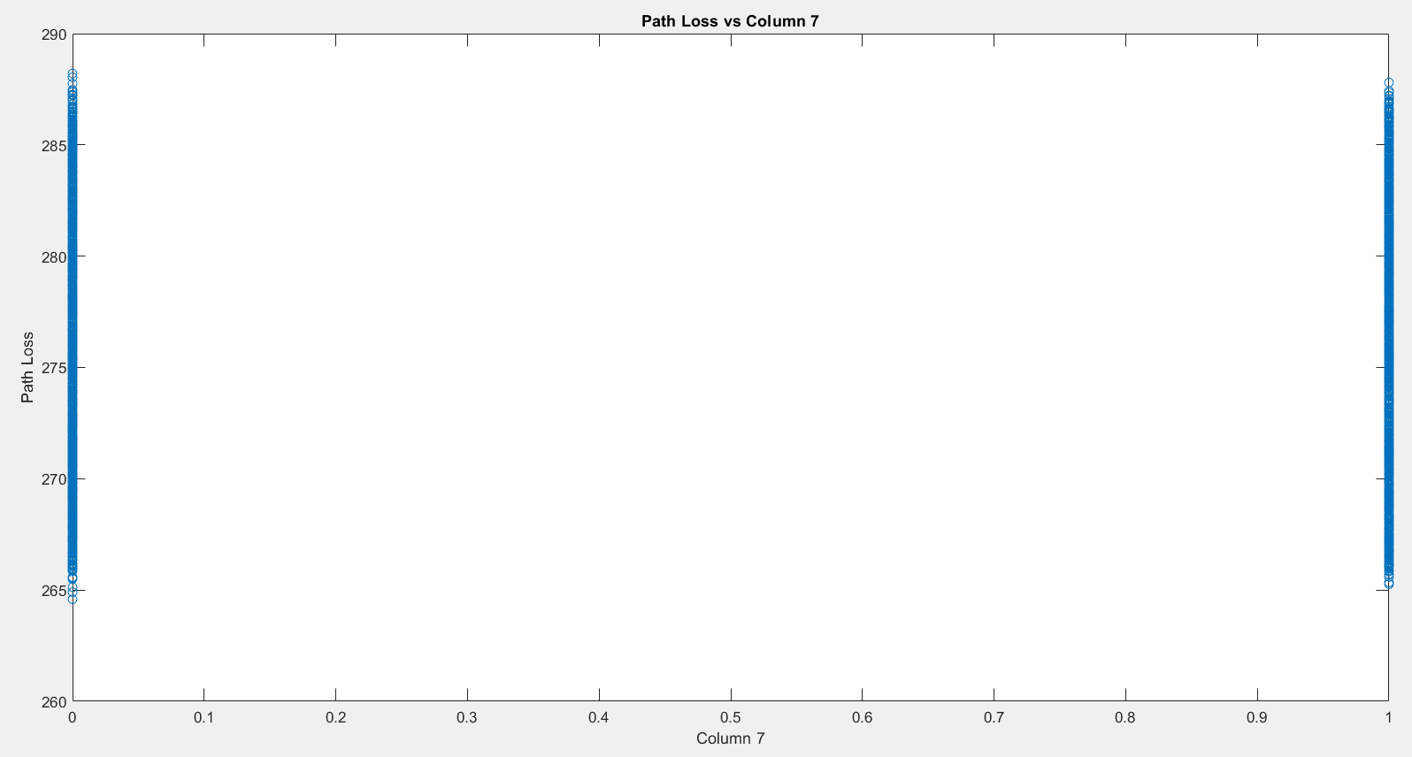

8) Path Loss vs Polarization Type:

vertical =1

horizontal =0

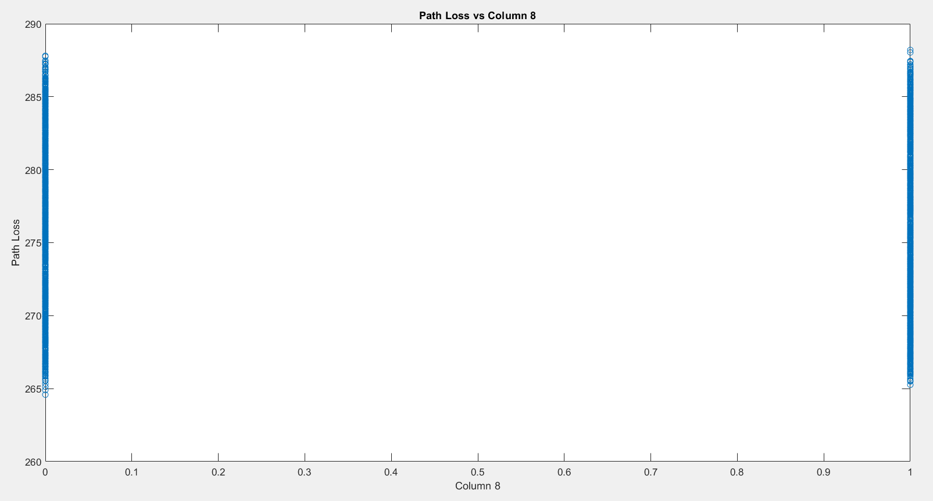

9) Path Loss vs Environment Type:

Desert = 0

Forest = 1

Mountainous = 2

Rural = 3

Suburban= 4

Urban = 5

Water = 6

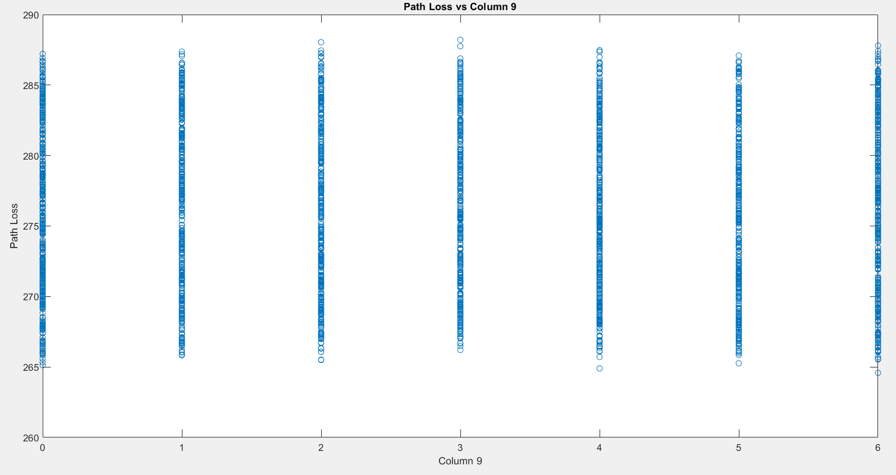

10) Path Loss vs Weather Conditions:

Rainy= 0

Snowy=1

Sunny=2

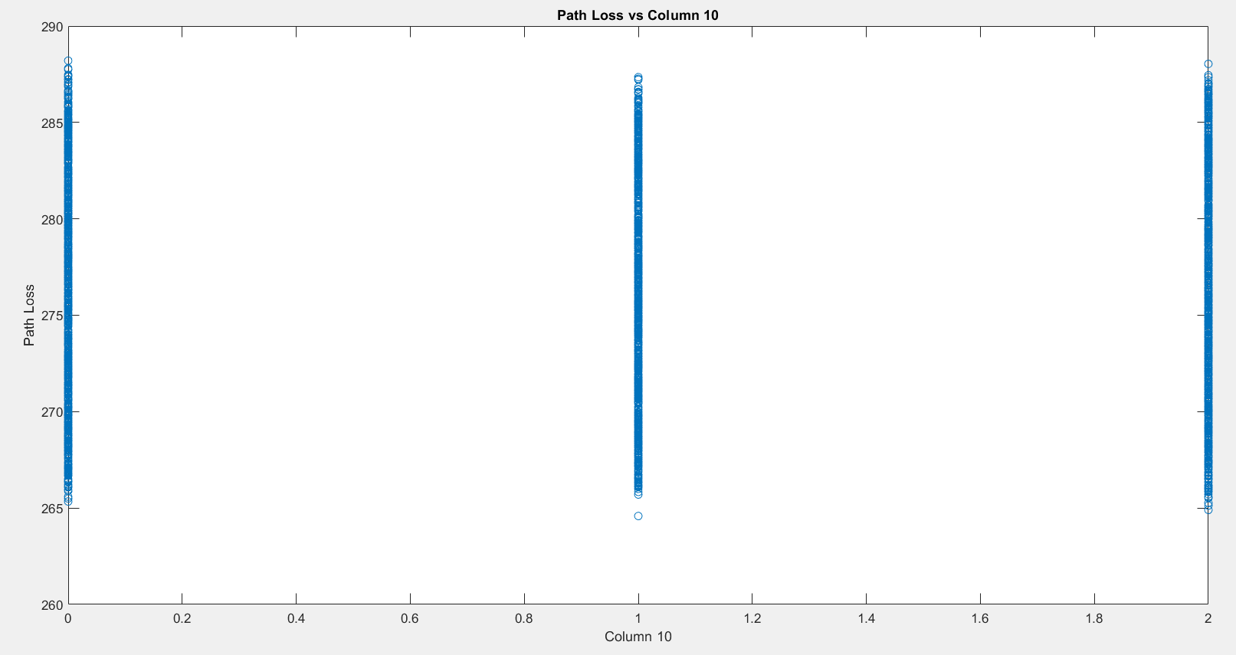

11) Path Loss vs Humidity levels:

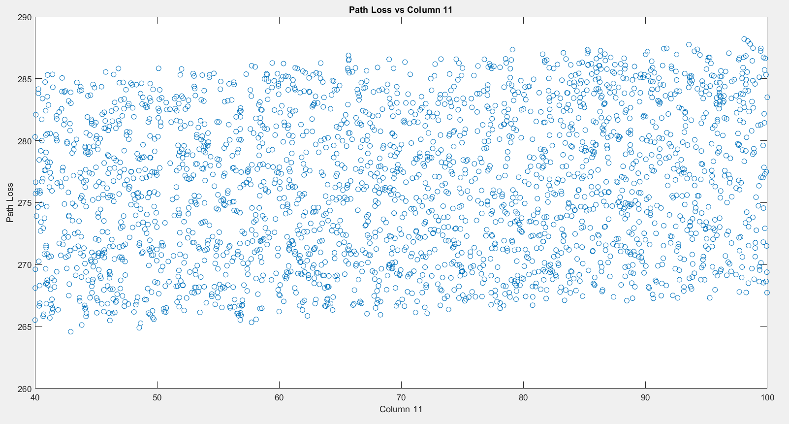

12) Path Loss vs Temperature:

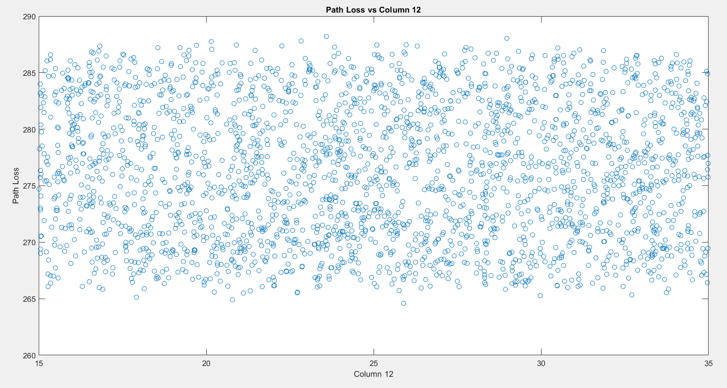

13) Path Loss vs Atmospheric Pressure:

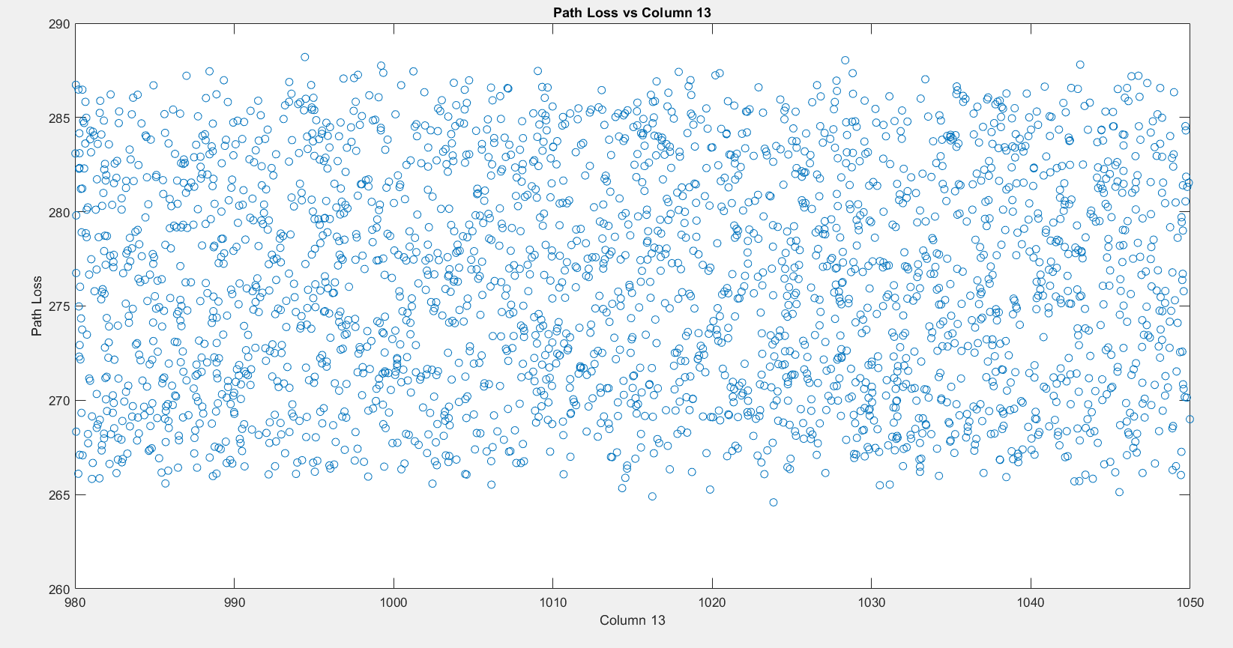

14) Path Loss vs Season:

Rainy season= 0

Summer= 1

Winter= 2

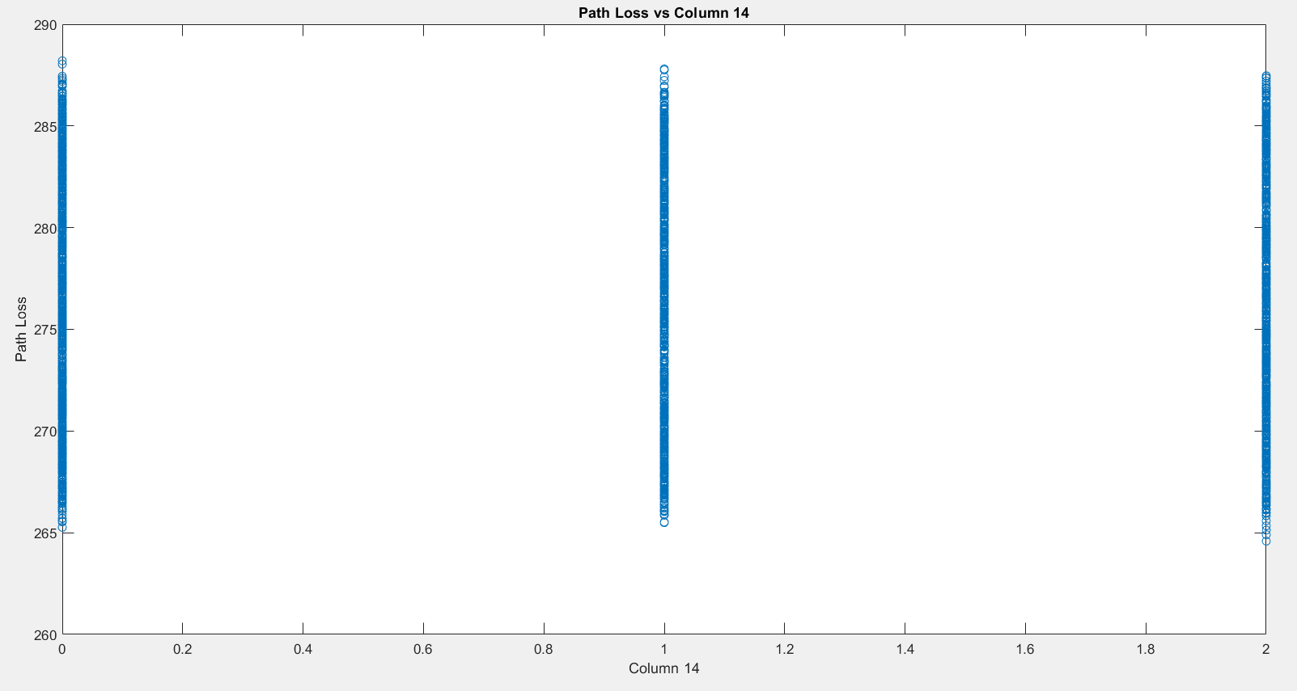

15) Path Loss vs Clutter Height:

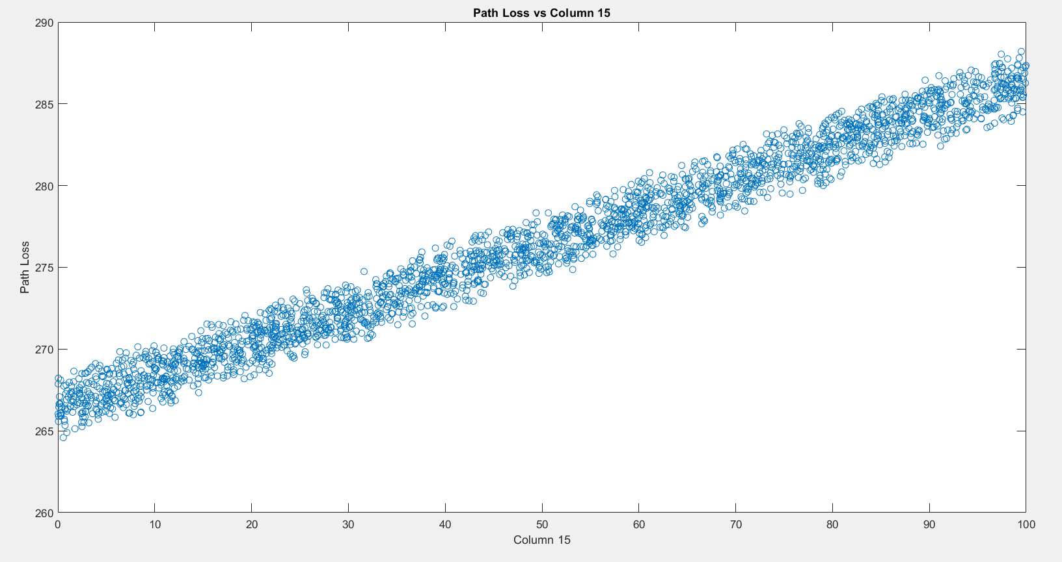

16) Path Loss vs Line of Sight:

Clear = 0

Obstructed = 1

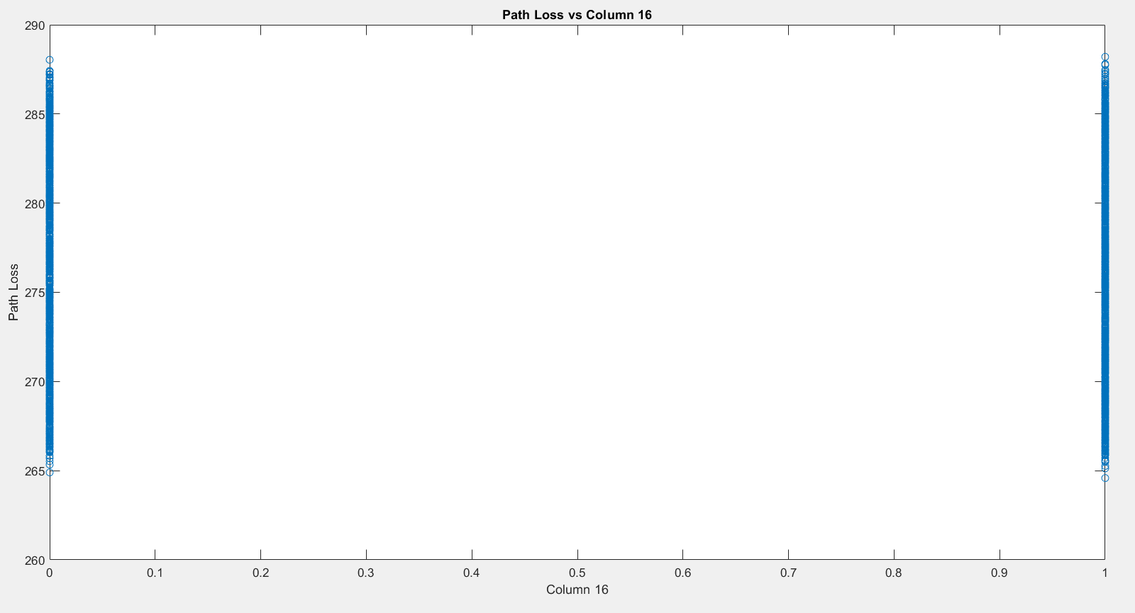

17) Path Loss vs Satellite Altitude:

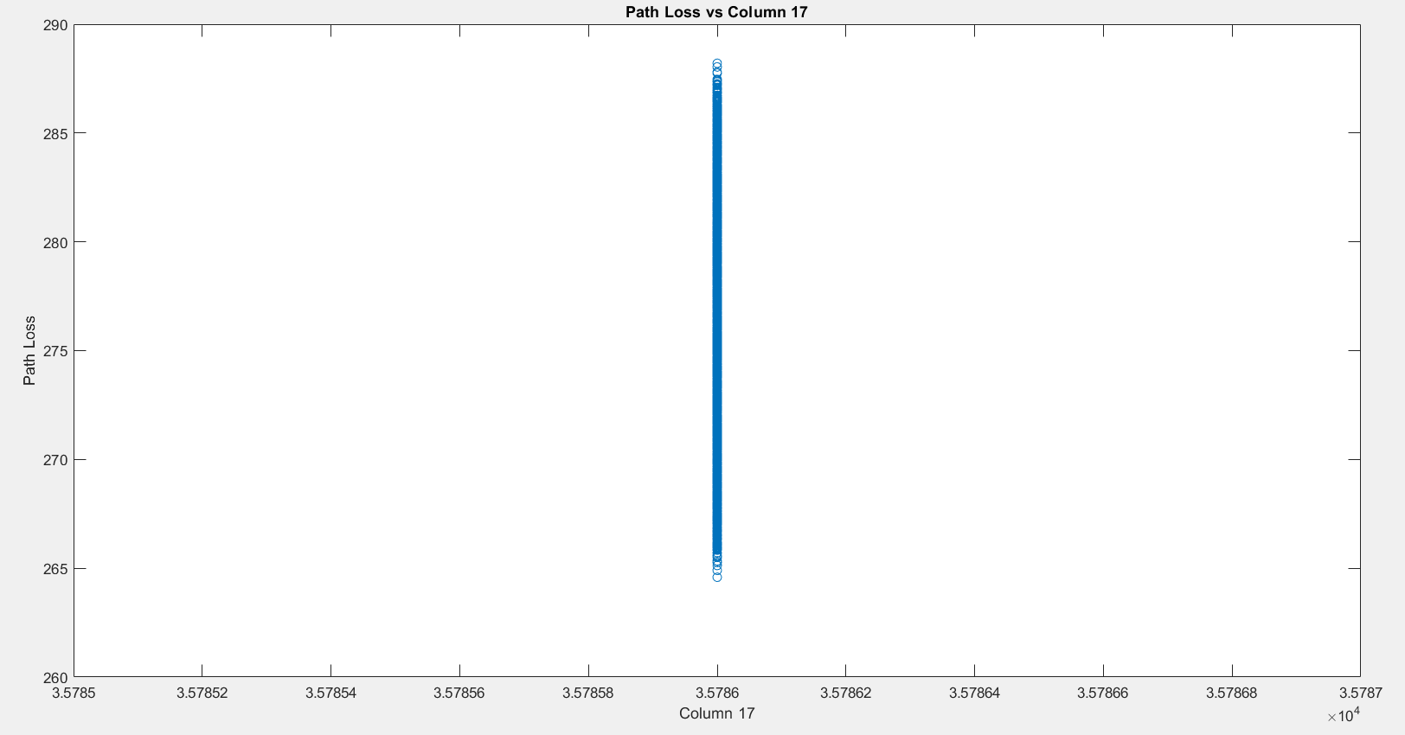

18) Satellite Position Latitude:

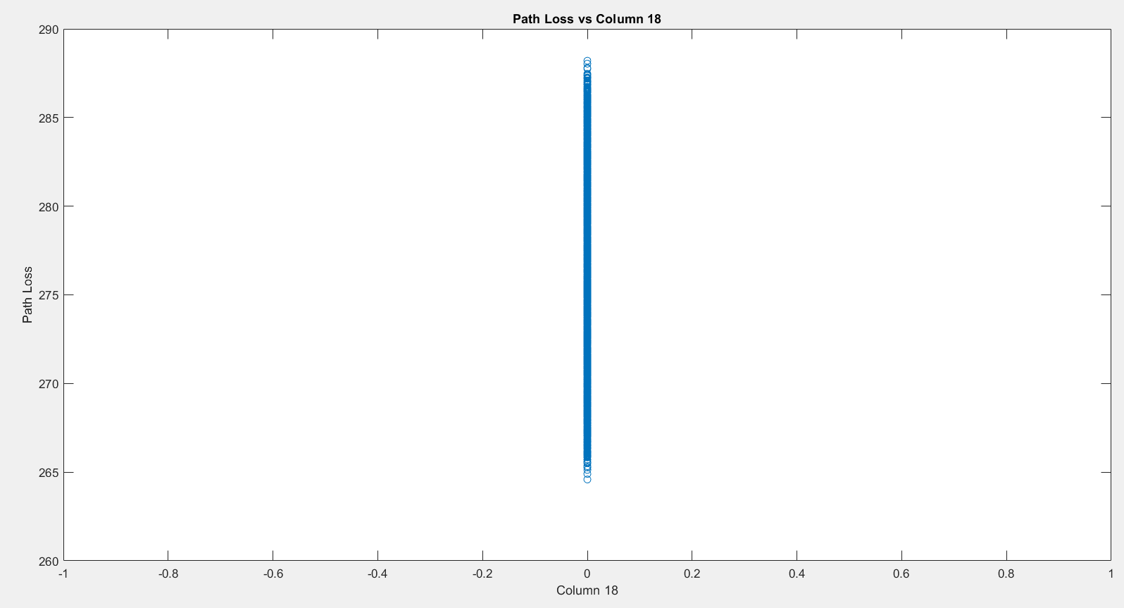

19) Satellite Position Longitude:

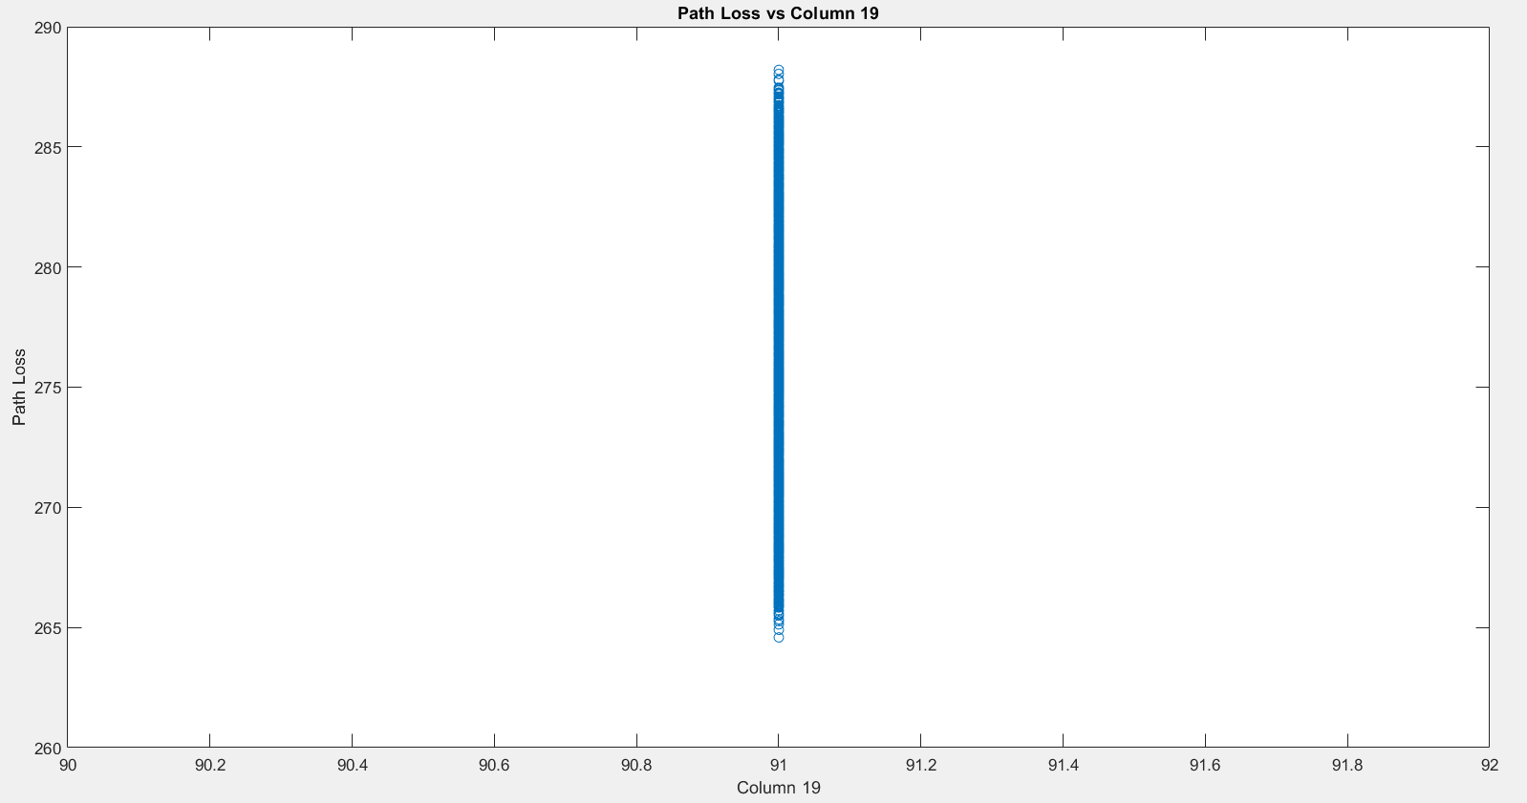

20) Path Loss vs Downlink Frequency:

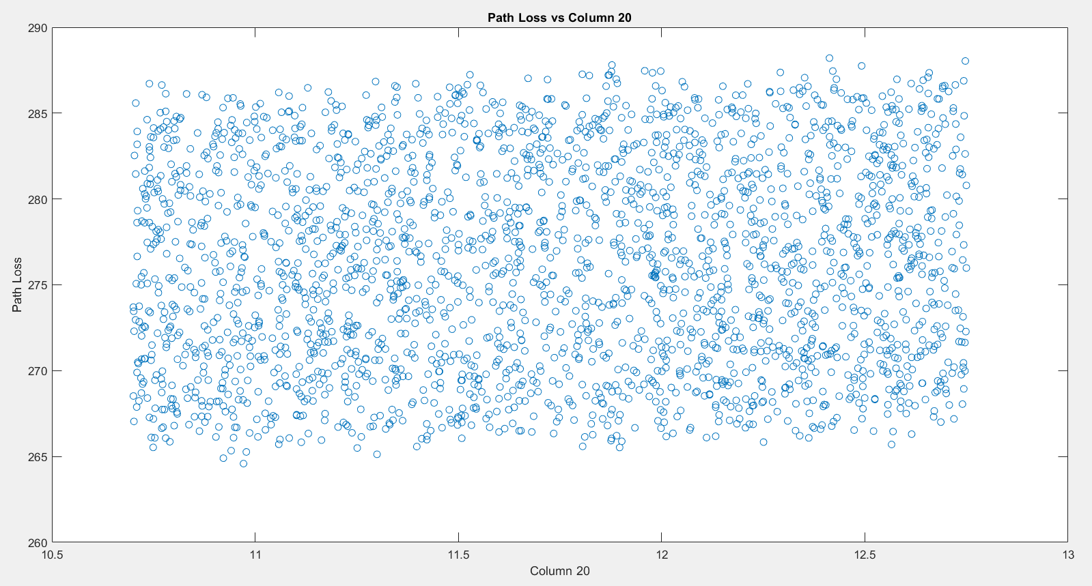

21) Path Loss vs Satellite Antenna Gain:

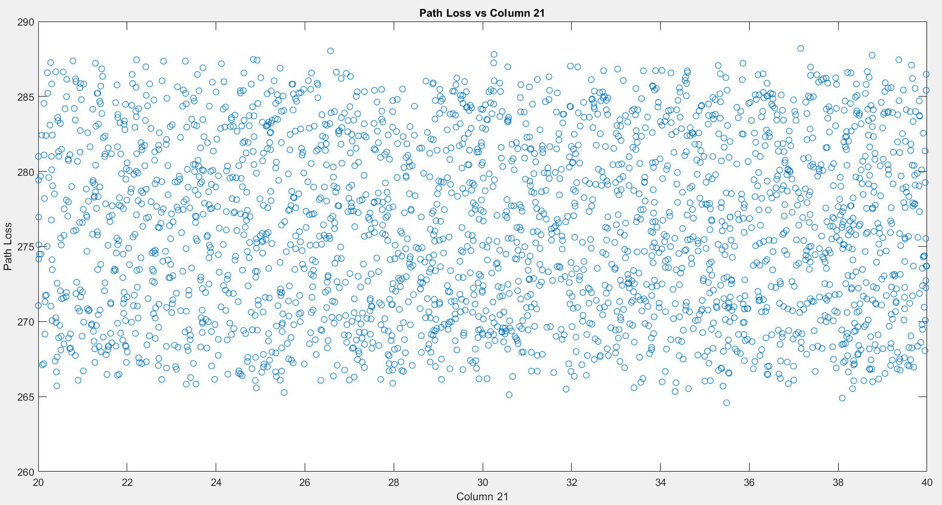

22) Path Loss vs Beam Type:

Narrow=0

Wide=1

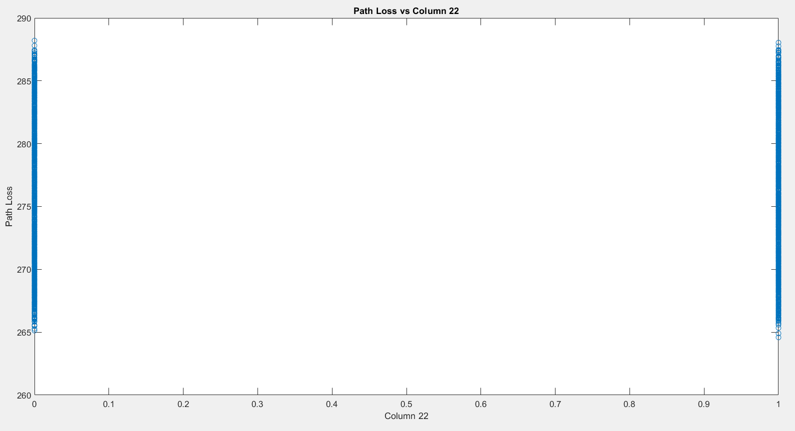

23) Path Loss vs Polarization Match:

Vertical=1

Horizontal=0

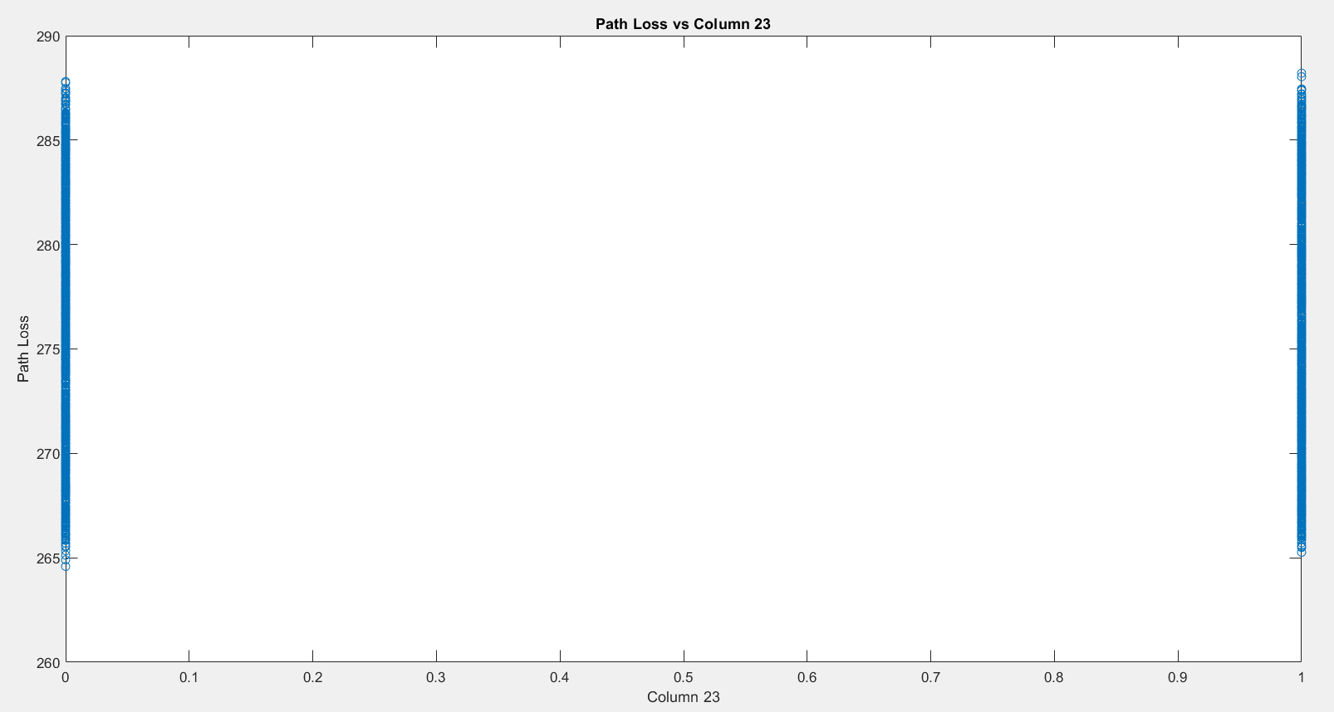

24) Path Loss vs Space Weather Condition:

Cosmic noise=0

Normal=1

Solar flare=2

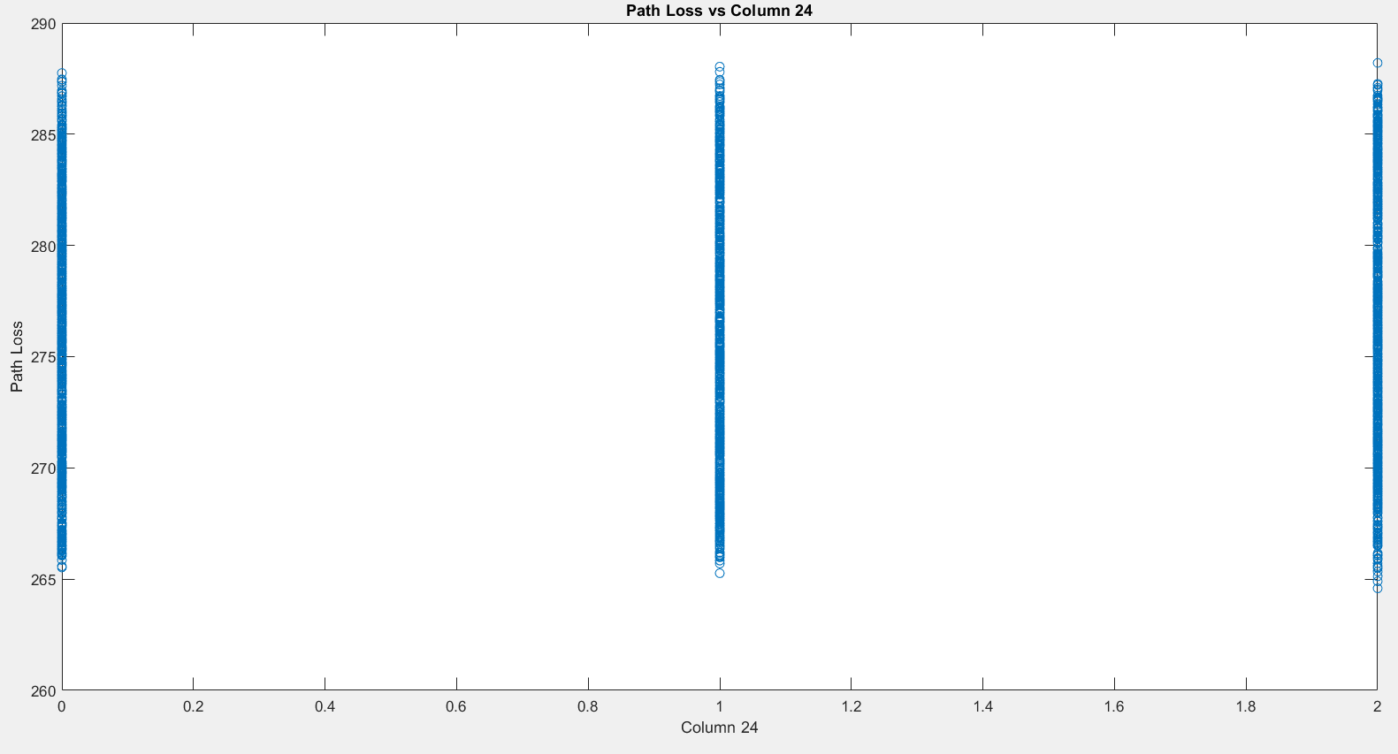

25) Path Loss vs Power Settings:

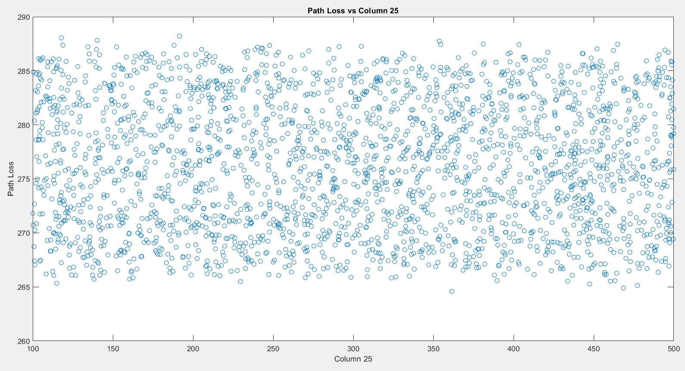

26) Path Loss vs Transmission Mode:

Burst = 0

Continuous= 1

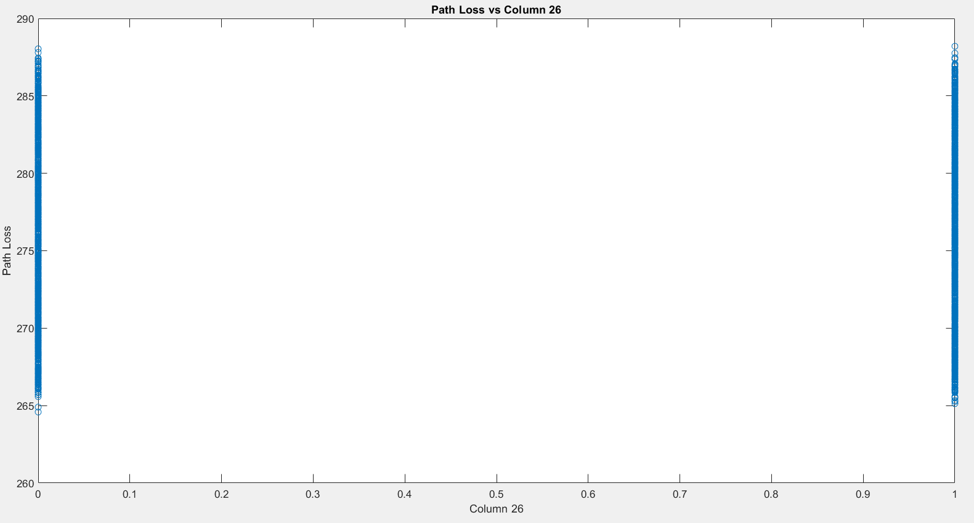

27) Path Loss vs Path Length:

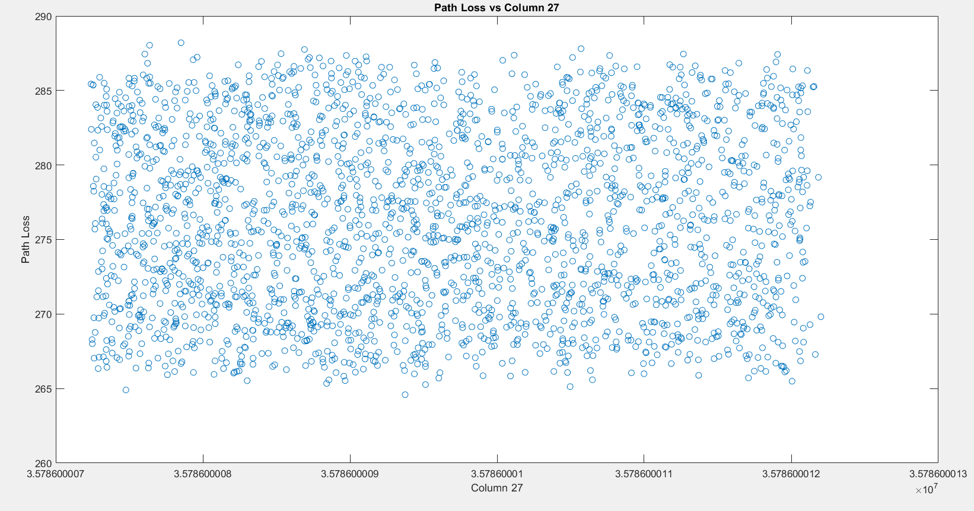

**Questions about the features:**

**1) column 1,2 here are "Latitude" and "Longitude". whose latitude and longitude they are?**

Answer: **Latitude and Longitude** refer to the geographic coordinates of the **ground station**. They indicate the specific location on Earth's surface from which the satellite communication is taking place.

**2) in column 3, whose elevation it is?**

Answer: The **elevation** refers to the height of the ground station above sea level. This is important because it can affect the line of sight to the satellite and the path loss experienced.

**3) Transmitter height in column 4, where is the transmitter basically? how does it transmit the data? what is the difference between elevation(column 3) and this transmitter height(column4)?**

Answer: The **transmitter** is typically located at the ground station, where it sends data to the satellite. It transmits data by converting electrical signals into radio waves that can travel through the atmosphere.  
**Difference**: Elevation (Column 3) is the height above sea level, while Transmitter Height (Column 4) refers specifically to how high the transmitter's antenna is above the ground level at the site of the ground station. If the ground station is on a hill, for example, the elevation might be higher than the actual height of the transmitter above the ground.

**4) what does polarization type mean (column 8)? explain!**

Answer: **Polarization Type** refers to the orientation of the electromagnetic waves emitted by the transmitter. Common types include horizontal and vertical polarization. The choice of polarization affects how well signals can penetrate obstacles and reduces interference with other signals. For satellite communications, matching polarization between transmitter and receiver is crucial for effective signal transmission.

**5) explain the weather condition(column 10)? which location's weather condition is this? is this the weather condition of where the transmitter is situated? or is this the weather condition where the satellite-ground-station is situated?**

Answer: The **weather condition** refers to the atmospheric state at the location of the ground station at the time of transmission. This is important because weather can significantly affect signal strength and path loss. The weather condition pertains to the site of the **ground station**, not the satellite's location.

**6) what is the unit of the atmospheric pressure (column 13)?**

Answer: The unit of **atmospheric pressure** is typically measured in **hPa** (hectopascals) or **mmHg** (millimeters of mercury). Common units also include **atm** (atmospheres) and **Pa** (pascals).

**7) what does clutter height mean (column 15)? explain!**

Answer: **Clutter Height** refers to the height of obstacles (like buildings, trees, etc.) in the vicinity of the ground station that could obstruct the line of sight to the satellite. Higher clutter height can lead to increased path loss due to diffraction and scattering of the signals.

**8) what does beam type (column 22) mean? explain!**

Answer: **Beam Type** describes the shape and coverage area of the satellite's transmission beam. Common types are **narrow beams** (which focus energy over a smaller area) and **wide beams** (which cover a broader area). Narrow beams are often used for targeted communications, while wide beams can cover larger regions.

**9) what does polarization match (column 23) mean? explain!**

Answer: **Polarization Match** means ensuring that the polarization of the transmitted signal (from the ground station) matches the polarization of the receiving antenna (on the satellite). This is essential for maximizing signal strength and reducing losses due to polarization mismatch.

**10) how are the space weather conditions (column 24)? explain!**

Answer: **Space Weather Conditions** refer to phenomena that occur in space, particularly solar activity (like solar flares and coronal mass ejections) that can affect satellite communications and navigation. These conditions can influence the ionosphere, causing variations in signal propagation.

**11) what do power settings (column 25) mean here? explain!**

Answer: **Power Settings** refer to the level of transmission power that the transmitter uses to send signals to the satellite. Higher power settings can improve signal strength but also may lead to increased interference. This setting is critical for ensuring that the transmitted signal reaches the satellite effectively.

**12) what does the transmission mode (column 26) mean? is it on the satellite-end or on the ground-station-end? whose transmission mode is this? explain!**

Answer: **Transmission Mode** indicates how the data is being sent (e.g., continuous or burst transmission). It can apply to both the ground station and satellite; however, in this context, it usually refers to the ground station's mode of transmission while sending data to the satellite.

**13) which path length is this (column 26)? From where to where?**

Answer: **Path Length** refers to the distance over which the signal travels from the ground station to the satellite. This is crucial for calculating path loss. The path length is essentially the distance between the transmitter at the ground station and the satellite in orbit.

**14) finally, what is the path loss of? is it the path loss of transmitter-to-receiver or ground station to satellite? explain the path!**

Answer: **Path Loss** indicates the reduction in signal strength as the signal travels from the ground station to the satellite. It accounts for various factors such as distance, atmospheric conditions, and obstacles. The path loss discussed here is primarily from the **ground station (transmitter) to the satellite (receiver)**, reflecting how much signal strength is lost during transmission.